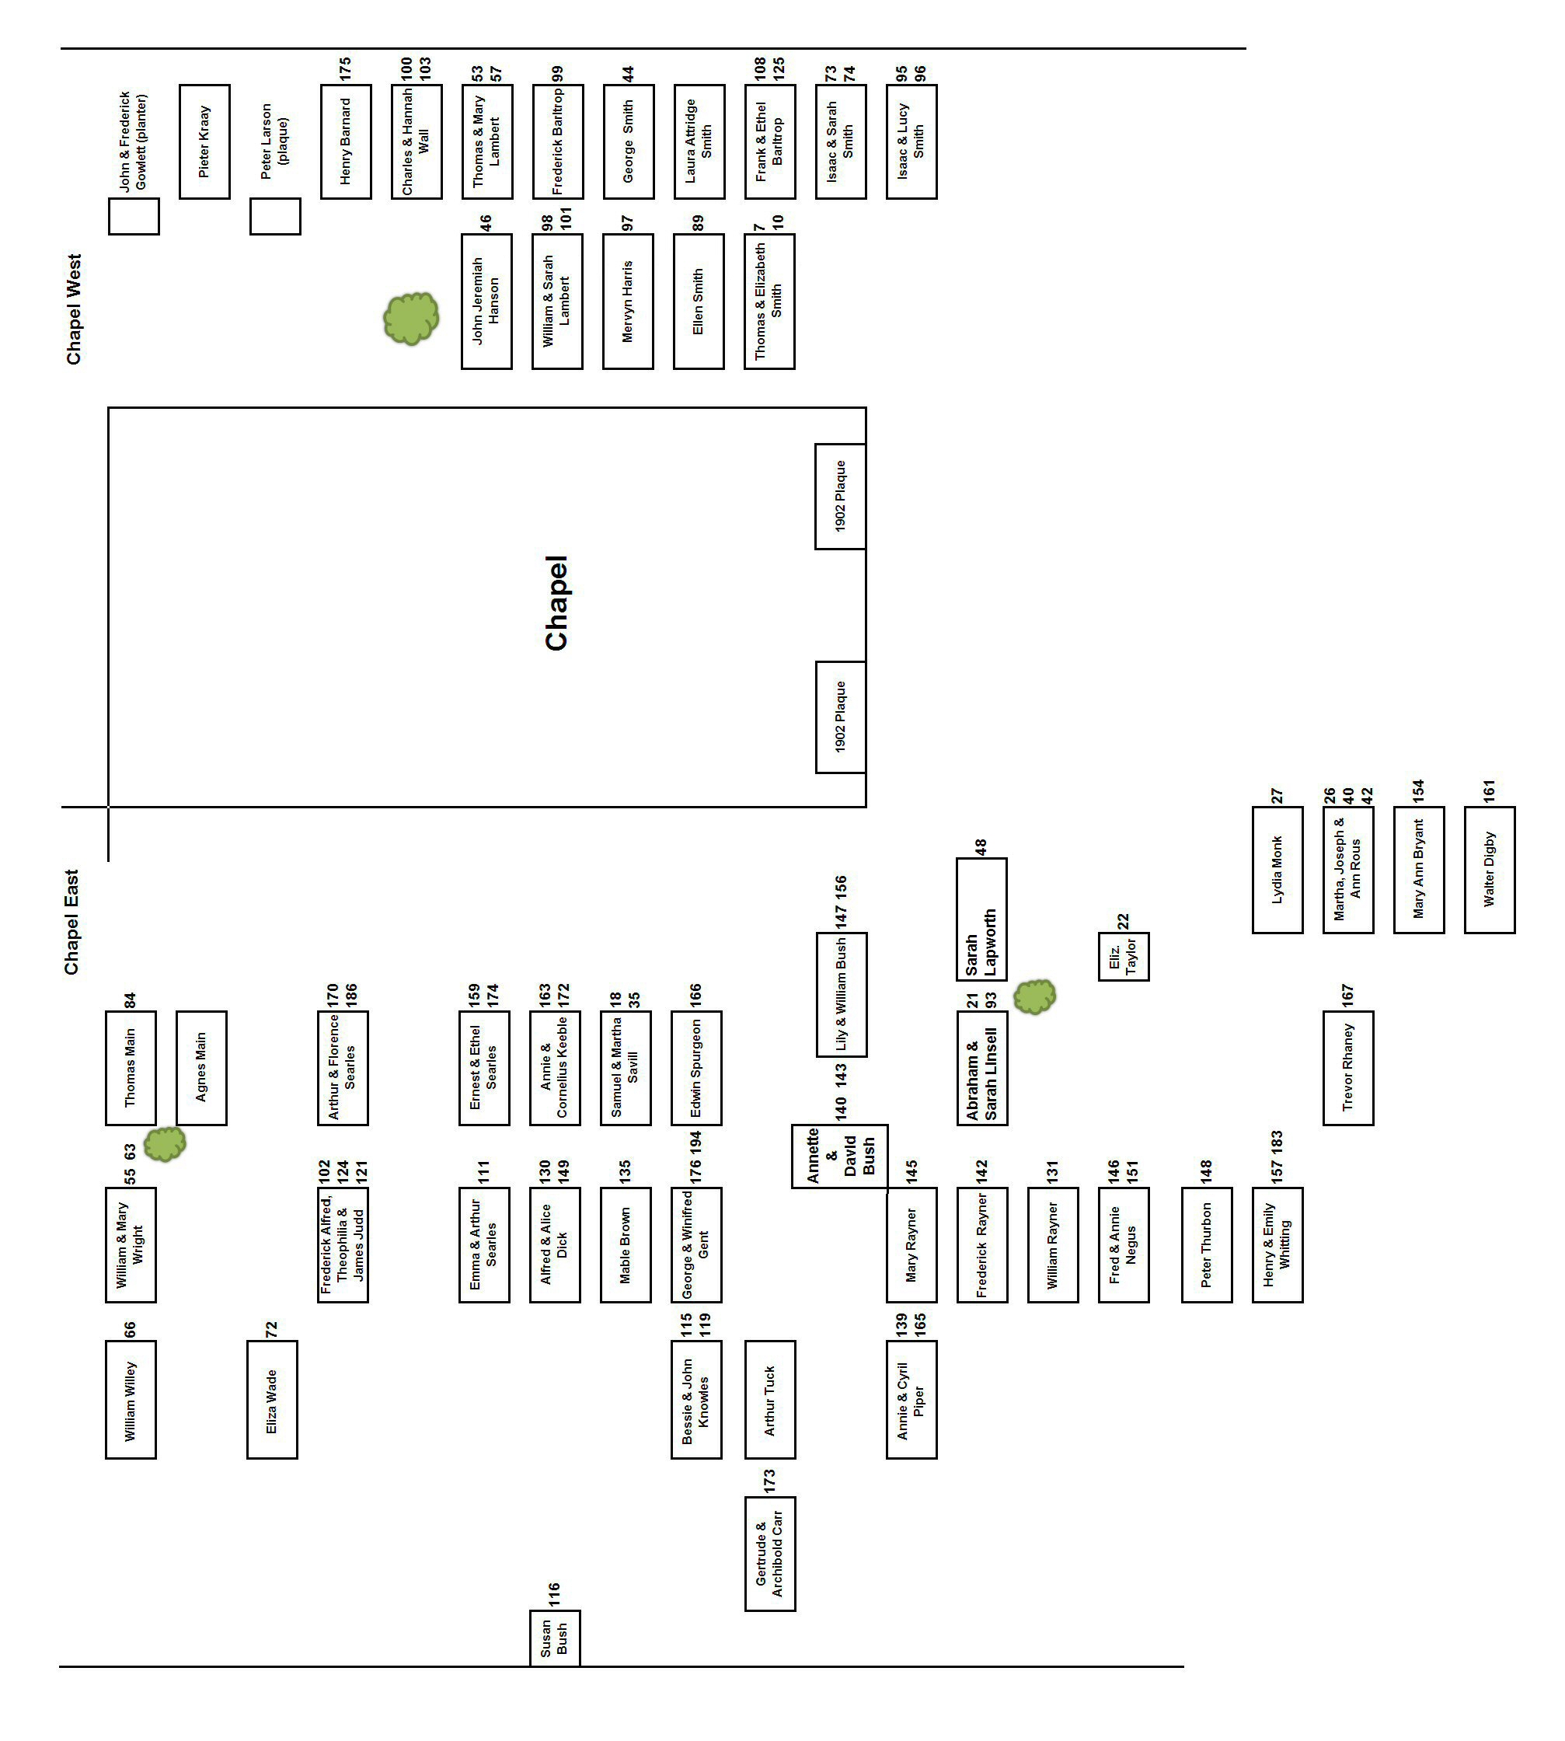
Takeley Chapel Memorial Inscriptions

Please Note: In August 2010 most stones in Chapel West were moved and laid flat while a portacabin was installed. This exposed some deep inscriptions and also uncovered the previously buried John and Mary Smith stone. The stones may be raised again but may not be in their original positions.

